Cortex Search Document Q&A — Technical Report

1. Overview
The project builds a retrieval-augmented generation (RAG) chat assistant that answers questions from your own PDF documents, running entirely inside Snowflake. It follows the Snowflake quickstart Ask Questions to Your Own Documents with Snowflake Cortex Search.
- Data: eight fictitious product manuals (bike and ski products) uploaded as PDFs.
- Goal: ground LLM answers in document context to reduce hallucinations, and let users compare answers with and without that context.
- Deliverables: a single-turn Q&A Streamlit app, a conversational chatbot with memory, and an automated pipeline that re-indexes new or removed documents.
- Prerequisites: a Snowflake account in a region that supports Cortex LLM functions, with Anaconda packages enabled by ORGADMIN.
2. Architecture
All components live in database CC_QUICKSTART_CORTEX_SEARCH_DOCS, schema DATA; no data leaves Snowflake.
Layer | Snowflake object / function | Role
Storage | Stage docs (SNOWFLAKE_SSE encryption, directory table enabled) | Holds the PDFs and tracks file metadata
Parsing | SNOWFLAKE.CORTEX.AI_PARSE_DOCUMENT (mode LAYOUT) → temp table RAW_TEXT | Extracts text from each PDF
Chunking | SNOWFLAKE.CORTEX.SPLIT_TEXT_RECURSIVE_CHARACTER (markdown, size 1512, overlap 256) | Splits text into chunks
Chunk store | DOCS_CHUNKS_TABLE (RELATIVE_PATH, SIZE, FILE_URL, SCOPED_FILE_URL, CHUNK, CHUNK_INDEX, CATEGORY) | Persists chunks with metadata
Classification | SNOWFLAKE.CORTEX.AI_CLASSIFY with labels Bike, Snow | Tags each document for filtering
Retrieval | Cortex Search service CC_SEARCH_SERVICE_CS on chunk, attribute category, warehouse COMPUTE_WH, TARGET_LAG 1 minute | Hybrid search index; embeddings created automatically
Generation | snowflake.cortex.complete / Complete with mistral-large2, llama3.1-70b, llama3.1-8b, snowflake-arctic | Produces the answer from prompt + context
Front end | Streamlit in Snowflake (Python 3.11, streamlit 1.42.0, snowflake.core 1.2.0) | Chat UI, model and category selectors
Automation | Streams insert_docs_stream, delete_docs_stream; procedure insert_delete_docs_sp(); task insert_delete_docs_task (every 5 minutes) | Re-processes added or removed documents

3. Flow Diagram
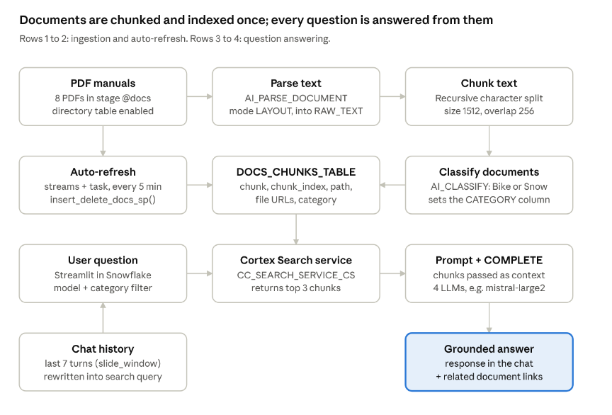
RAG flow · ingestion, auto-refresh and question answering
Ingestion turns PDFs into classified chunks that Cortex Search indexes; at query time the top 3 chunks are passed to the LLM, and in the chatbot the chat history is first rewritten into a standalone search query.
4. Output
The output is a working product chat assistant in Streamlit that answers from the manuals and shows where each answer came from.
- Answer panel: the LLM response to the user's question; a checkbox "Use your own documents as context?" switches between RAG and plain prompting.
- Sidebar: the model selector, the category filter (ALL, Bike, Snow), the raw search results as JSON, and a "Related Documents" expander with presigned links (GET_PRESIGNED_URL, 360 s) to the source PDFs.
- Chatbot version: chat history in st.session_state.messages, a "Start Over" button, and a debug view of the standalone query generated from history.
- Example results from the guide: the lubricant question returns "Premium Oil 2287"; after the manual is replaced, it returns "Premium Oil 5555"; after the ski boots manual is removed, the app replies that the context does not mention anyone testing ski boots.
5. Evaluation Metrics
The guide defines no quantitative metrics (no precision, recall or framework such as TruLens); evaluation is qualitative, by testing known questions against the manuals.
Criterion | How the guide checks it
Answer correctness | Known-answer questions, e.g. the premium bike lubricant should point to "Premium Oil 2287"
Grounding / no hallucination | Compare answers with the context checkbox on vs off; the prompt tells the model to say when information is missing
Retrieval relevance | Inspect the chunks returned in the sidebar JSON and the related-document links
Model comparison | Switch between the four LLMs; "you will notice different performance depending on the LLM you use"
Freshness | After replacing or removing a PDF, answers should reflect the change (Premium Oil 5555; ski boots no longer found)
Conversational coherence | Follow-up questions keep context only in the chatbot version with chat history on
Tuning levers named in the guide: number of chunks (NUM_CHUNKS = 3), chunk size (Snowflake recommends no more than 512 tokens per chunk), prompt wording, and chat window size (slide_window = 7).
6. Inferences
RAG on Snowflake can be built end to end with SQL functions and Streamlit, keeping data and governance inside the platform.
- Context reduces hallucination: with document context, answers cite product-specific facts; without it, LLMs "can sometimes guess or provide incorrect responses."
- Managed retrieval simplifies the stack: Cortex Search creates embeddings and refreshes the index on its target lag, so no separate vector database or embedding pipeline is needed.
- Metadata improves precision: classifying documents into Bike / Snow lets users filter retrieval to the relevant product line.
- Memory needs query rewriting: single-turn Q&A loses context on follow-ups; summarising history into a standalone query fixes this in the chatbot.
- Model choice matters: quality varies across the four LLMs, so the selector is useful for picking one per use case.
- The index stays current: streams plus a scheduled task keep answers aligned with the latest documents without manual reprocessing.

Screen Shots to showcase the automatic processing of records

Before deleting the file ‘Premium_Bicycle_User_Guide.pdf’, question shows value as Premium Oil 2287.
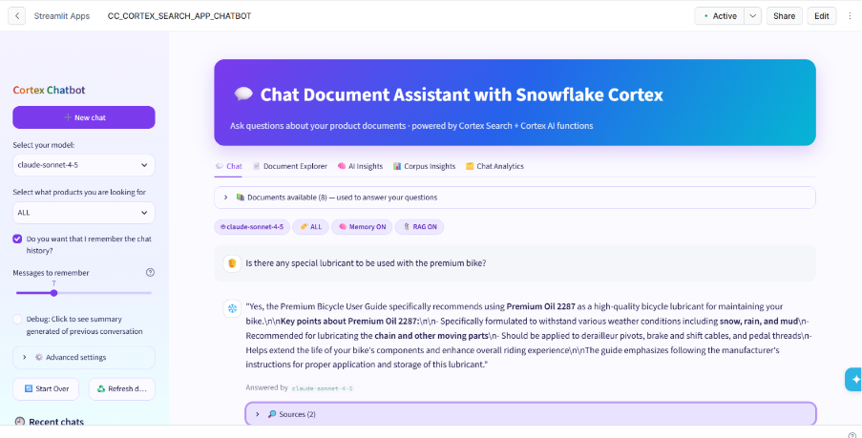
Deleting the document and loading an updated one using streams and task as automation.
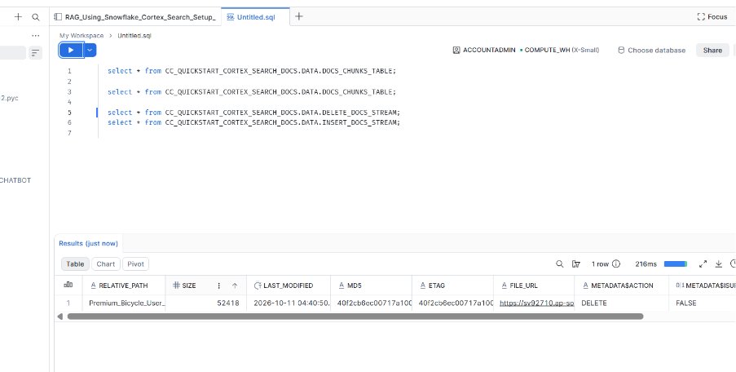

With an updated document value for the same question has been updated to Premium Oil 5555. Also, in this stream we have saved chat options so previous value can also be seen by switching.

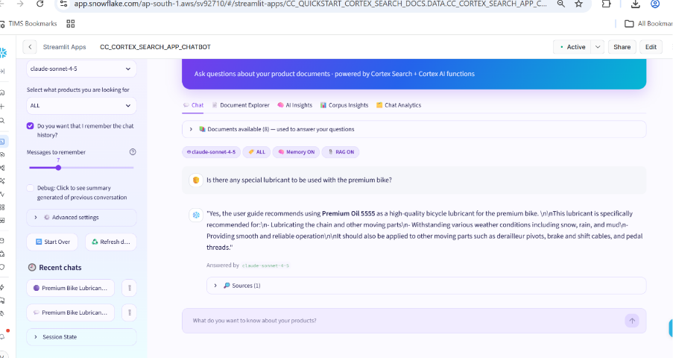

7. Challenges

During the course of development most of the code ran properly and creates no issues.
For creating streamlit application, code was very old and giving an error, when I took help from CoCo it got resolved and code also get uplifted. Below are the screen shots of same.

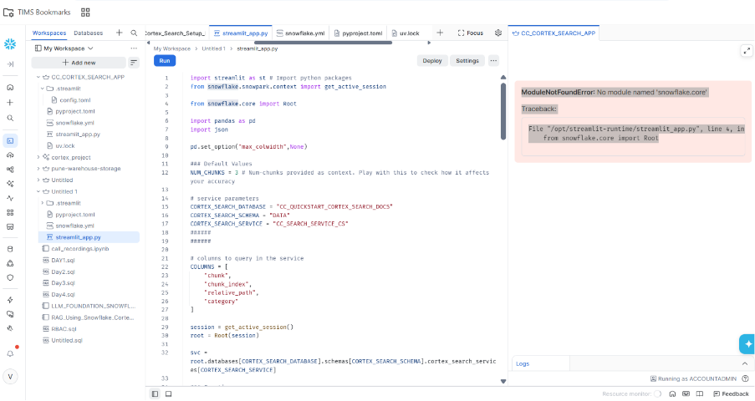

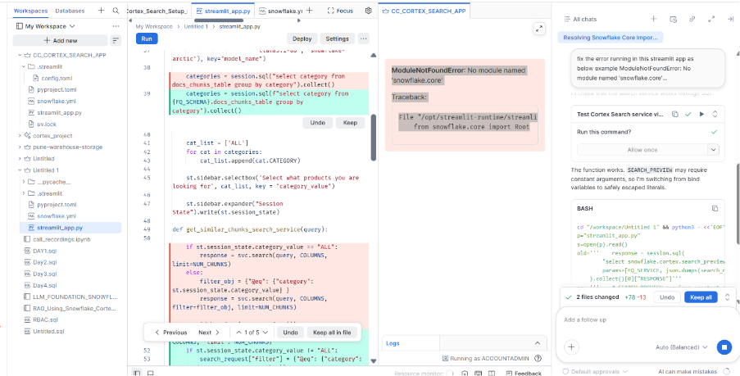
Summary of changes as below:

- Removed the snowflake.core import. Search now goes through the SNOWFLAKE.CORTEX.SEARCH_PREVIEW SQL function, which I tested earlier against your search service and it returned results.
- Connection: I switched to st.connection("snowflake", ...).
- Full names: the docs_chunks_table table, the @docs stage and the search service are referenced by their full names under CC_QUICKSTART_CORTEX_SEARCH_DOCS.DATA.
- Safer document links: the file path in the document-link query is passed as a parameter rather than pasted into the SQL.

APPENDIX
Actual Flow

Documents (PDF/DOCX)
↓
Stage (@DOCS)
↓
DIRECTORY(@DOCS)
↓
AI_PARSE_DOCUMENT
↓
SPLIT_TEXT_RECURSIVE_CHARACTER
↓
DOCS_CHUNKS_TABLE
↓
CORTEX SEARCH SERVICE
↓
Semantic Search / RAG / Chat Applications
Pasting screen shots from my code

